How to Register for Online Services:

1. On the Town of Oliver homepage choose the Online Services tab.

2. The home page for Online Services will display. Choose register from the top right side of the page.

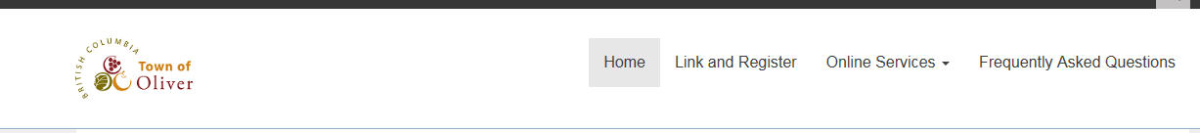

3. The Welcome to Online Services registration page will display. If you are already registered you can log in by entering your user name and password. If you are registering click the show me how button.

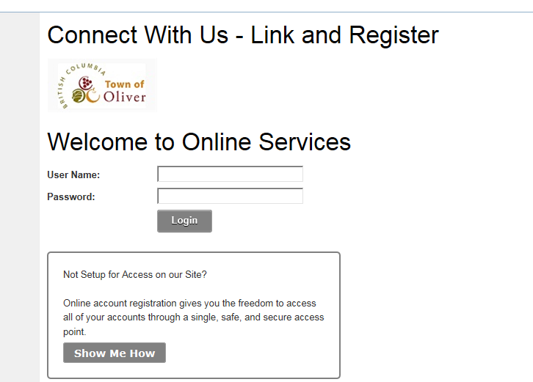
You may choose a user name and a display name. They can both be the same or you may choose a different name for each. The user name will be the name you use to log in. The display name will be the name displayed when you are logged into Online Services.

4. The Connect With Us – Link and Register screen will appear. Select property taxes as the account type.

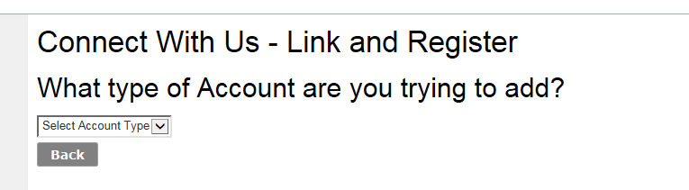

5. The property tax account detail screen will display.

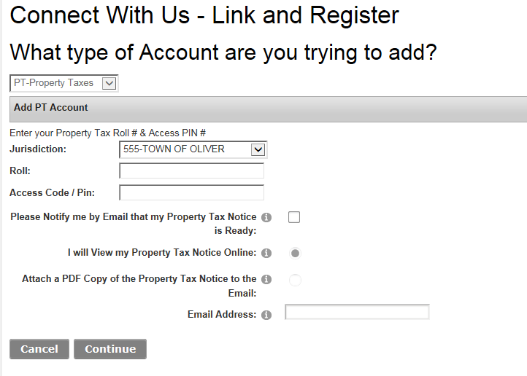

6. The jurisdiction field will automatically default to the Town of Oliver. Enter the roll number as the 8 digits after the 555 account number (including the decimal) and your access code from your most recent property tax notice. Then click continue

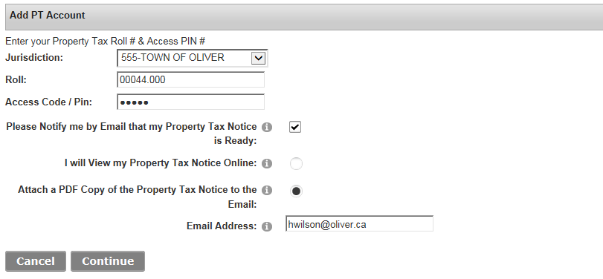
You have the option of viewing your tax notice online or attaching a PDF of the notice to an email. Tick the appropriate box (you cannot choose both). The email address defaults to the address that you used to register the account.
If you wish to be notified by email when your tax notice is ready you must click the notify box.

7. Complete the personal information on the screen. Choose a user name (this name will be the name you use to log in) and a password (the password must be at least 7 characters). Click save.

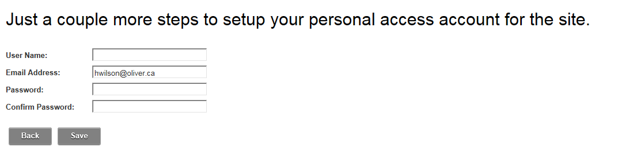

8. Once registered you will see your tax displayed and that it is linked. If you have more than one property you can add another account by clicking “need to add an account.” To see your account details click on the property tax account.

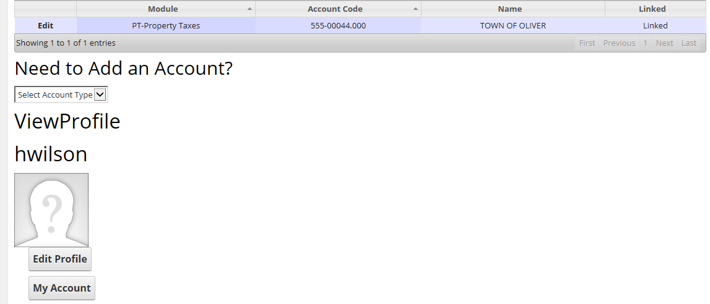

9. Property tax details will be displayed once you click on the tax account. If there is more than one owner on a property, all property owners can register with the same account code, however you cannot use the same user name.

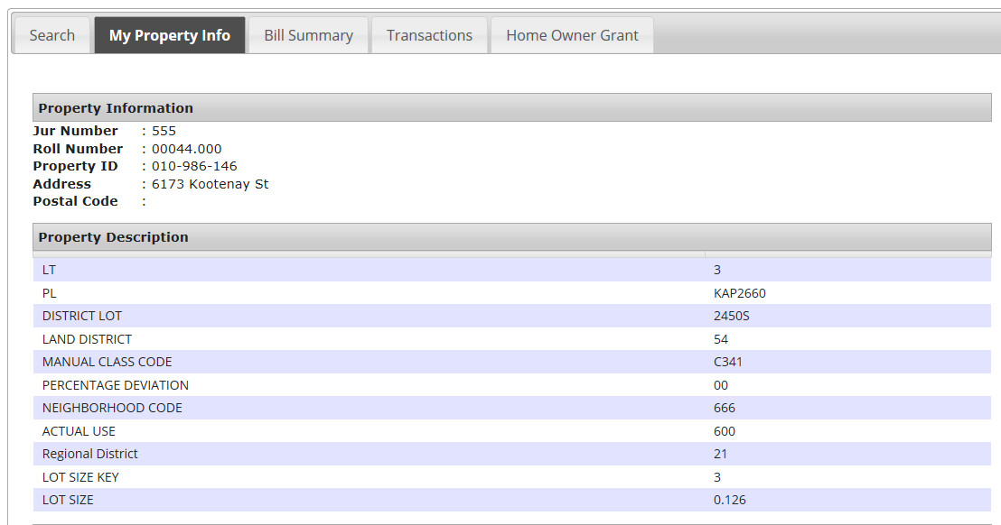

10. You will receive notification that you have registered for Online Services with your log in and password.

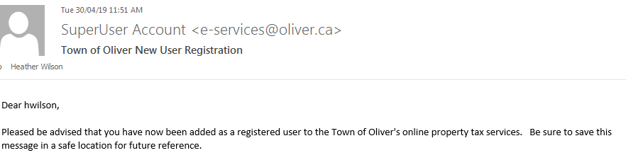

11. If you have chosen to receive your property tax notice by email, you will receive a notification when your notice is ready with a link to open the notice.

12. You will now see your login name at the top right hand corner as well as the log out.

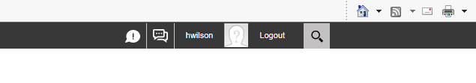
13. Click log out to leave your Online Services account. If any questions please contact the Finance Department at finance@oliver.ca or 250-485-6203.

